Supplementary Information
Table S1. Bacterial strains and plasmids used in this study.
Strains | Description | Reference or Source
E. coli Top 10 | Clone strain | Our lab
B. subtilis WB600 |  | Our lab
B. amyloliquefaciens |  | Our lab
B. licheniformis WX-02 |  | Our lab
B. vietamensis |  | This study
151-6 | Wild type | This study
151-6△5 and 151-6△7 | The p6 plasmid was deleted | This study
B. marisflavi |  | This study
151-25 | Wild type | This study
151-25△3 and 151-25△29 | The p25 plasmid was deleted | This study
Plasmids
pUC19 | E. coli clone vector | Our lab
4087-4088- pUC19 | 151-6 chromosomal fragment containing orf4087, orf4088 and 230-bp upstream of orf4088 were inserted into pUC19
4093-4094-4095- pUC19 | 151-6 chromosomal fragment containing orf4093, orf4094, orf4095 and 271-bp upstream of orf4095 were inserted into pUC19
4102-4103- pUC19 | 151-6 chromosomal fragment containing orf4102, orf4103 and 262-bp upstream of orf4103 were inserted into pUC19
4108-4109- pUC19 | 151-6 chromosomal fragment containing orf4108, orf4109 and 220-bp upstream of orf4108 were inserted into pUC19
4111-4112-4113- pUC19 | 151-6 chromosomal fragment containing orf4111, orf4112, orf4113 and 217-bp upstream of orf4113 were inserted into pUC19 | This study
4774-4775- pUC19 | 151-25 p25 plasmid frsgement containing orf4774 and orf4775 were inserted into pUC19 | This study
4776-4777- pUC19 | 151-25 p25 plasmid frsgement containing orf4776, orf4777 and 427-bp upstream of orf4777 were inserted into pUC19 | This study
4779-4780- pUC19 | 151-25 p25 plasmid frsgement containing orf4779 and orf4780 were inserted into pUC19 | This study
4781-4782- pUC19 | 151-25 p25 plasmid frsgement containing orf4781, orf4782 and 309-bp upstream of orf4782 were inserted into pUC19 | This study
4802-4803-pUC19 | 151-25 p25 plasmid frsgement containing orf4802, orf4803 and 878-bp upstream of orf4802 were inserted into pUC19 | This study
pUBC19 | E. coli-B. subtilis shuttle vector | Our lab
4087-4088- pUBC19 | 151-6 chromosomal fragment containing orf4087, orf4088 and 230-bp upstream of orf4088 were inserted into pUBC19
4093-4094-4095- pUBC19 | 151-6 chromosomal fragment containing orf4093, orf4094, orf4095 and 271-bp upstream of orf4095 were inserted into pUBC19
4102-4103- pUBC19 | 151-6 chromosomal fragment containing orf4102, orf4103 and 262-bp upstream of orf4103 were inserted into pUBC19
4108-4109- pUBC19 | 151-6 chromosomal fragment containing orf4108, orf4109 and 220-bp upstream of orf4108 were inserted into pUBC19
4111-4112-4113- pUBC19 | 151-6 chromosomal fragment containing orf4111, orf4112, orf4113 and 217-bp upstream of orf4113 were inserted into pUBC19 | This study
4774-4775- pUBC19 | 151-25 p25 plasmid frsgement containing orf4774 and orf4775 were inserted into pUBC19 | This study
4776-4777- pUBC19 | 151-25 p25 plasmid frsgement containing orf4776, orf4777 and 427-bp upstream of orf4777 were inserted into pUBC19 | This study
4779-4780- pUBC19 | 151-25 p25 plasmid frsgement containing orf4779 and orf4780 were inserted into pUBC19 | This study
4781-4782- pUBC19 | 151-25 p25 plasmid frsgement containing orf4781, orf4782 and 309-bp upstream of orf4782 were inserted into pUBC19 | This study
4802-4803-pUBC19 | 151-25 p25 plasmid frsgement containing orf4802, orf4803 and 878-bp upstream of orf4802 were inserted into pUBC19 | This study
666-667-668-pUBC19 | 151-25 chromosome frsgement containing orf666, orf667, orf668 and 268-bp upstream of orf666 were inserted into pUBC19 | This study
1240-1241-pUBC19 | 151-25 chromosome frsgement containing orf1240, orf1241 and 260-bp upstream of orf1240 were inserted into pUBC19 | This study
3892-3894-pUBC19 | 151-25 chromosome frsgement containing orf3892, orf3893, orf3894 and 303-bp upstream of orf3894 were inserted into pUBC19 | This study

Table S2. Primers used in this study.
Primer | Sequence (5’-3’)ª
Verification of the elimination of the plasmid p25
4163CDS-F | TTGACAGAAGGGGAAGCGGTTG
4163CDS-R | TTAGAATGGAGAAGAAAAGATA
4779CDS-F | ATGGAGTTTACCACTAGCTATG
4779CDS-R | TTAGTTGGTTGTTTTACGCATG
4780CDS-F | GTGAACGGGCAAAGGAAGTACA
4780CDS-R | TTATCCACAAGTGCCGGTTGGA
4803CDS-F | GTGATTAAGAAAGATACTTGTG
4803CDS-R | CTAGACATTGATCTTCACCTCT
Verification of the elimination of the plasmid p6
4108CDS-F | ATGAAAAAAAGAAAGAGAAGATTGG
4108CDS-R | TTATTGTTCTGGCTTGATCA
4109CDS-F | ATGTCCATAGATGAATTAAATAACC
4109CDS-R | CTAGAATCCCGTAAAACCAC
4963CDS-F | GTGTTATCCGAAAACAAAAA
4963CDS-R | TTATTCGAATACCTCCTCTG
4967 CDS-F | ATGAAACATAAACCAATCGC
4967 CDS-R | CTACTCATTAGGTCGAAACG
4982 CDS-F | ATGAGCGTTCGGTTTCAATT
4982 CDS-R | TCATTGCAACTCCTCTCTAA
4983 CDS-F | ATGAATGAGCGATCGAAAGA
4983 CDS-R | TCAAATTGAAACCGAACGCT
5014 CDS-F | ATGTTCAGTGGTCCCGGGGTGAT
5014 CDS-R | TTAGAAATCGAAACTCAATTGCT
5018 CDS-F | GTGAGCCAAGTACCTTACAT
5018 CDS-R | TCAGGCACTTCTACGTTTAG
16S rRNA gene amplifying primers
16S rRNA-F | AGAGTTTGATCCTGGCTCAG
16S rRNA-R | GGTTACCTTGTTACGACTT
pUC19 sequencing primers
M13-F | CGCCAGGGTTTTCCCAGTCACGAC
M13-R | AGCGGATAACAATTTCACACAGGA
pUBC19 sequencing primers
CX-F | GGTACAAGAAAAACGAGGAAAGATGC
CX-R | TCGTATGTTGTGTGGAATTGTGAGC
pCC1 sequencing primers
pCC1-F | GGATGTGCTGCAAGGCGATTAAGTTGG
pCC1-R | CTCGTATGTTGTGTGGAATTGTGAGC
Operon of B. marisflavi 151-25
4774-4775-F | ataGAGCTCACGAACACAGCTCGATGACT
4774-4775-R | ataTCTAGACTACAGATCTTTAAAAGTCC
4776-4777-F | ataGAGCTCTACTATTCTCTTCCTAATAGAA
4776-4777-R | ataTCTAGATCACTTGCTCCTGCCCTTCA
4779-4780-F | ataGGTACCTTATCCACAAGTGCCGGTTGGAT
4779-4780-R | ataTCTAGATTAGTTGGTTGTTTTACGCATGA
4781+4782-F | ataGAGCTCTGCCAAGAGACAAAAGACCA
4781+4782-R | ataTCTAGATTACTCCACCTTTCCCTTTG
4082-4803-F | ataGGTACCTTTATATCAGTAGACTGTACTCT
4082-4803-R | ataTCTAGACTATTCTTTGATTTTCAATAAG
666-667-668-F | ataGGTACCTTCAAAGTAAGCCGGATCCT
666-667-668-R | ataTCTAGATTATACATAGATTGATAGTCGC
1240-1241-F | ataGGTACCACTGCCGCCCTTCCTGATTT
1240-1241-R | ataTCTAGATCAACCCTGTTTCTTTTCCC
3892-3894-F | ataGGTACCCTGAGGATCAGACGATCACG
3892-3894-R | ataTCTAGATTACCTTTGCTCTGAAGCTT
Operon of B. vietamensis 151-6
4087-4088-F1 | ataGGATCCGCTTCAGAAGTTGGAACAAA
4087-4088-R1 | ataGTCGACCTATTTTACTTTTAAAAGGC
4087-4088-F2 | ataCTCGAGGCTTCAGAAGTTGGAACAAA
4087-4088-R2 | ataTCTAGACTATTTTACTTTTAAAAGGC
4093-4094-4095-F | ataGAGCTCTTGTTTTACCACCCTTCACATAT
4093-4094-4095-R | ataTCTAGATTATATAGCTTTTTGTTTTTCCCCC
4102-4103-F | ataGAGCTCGTAATGATTTGAATAAGATAACC
4102-4103-R | ataTCTAGACTAGTTTTCTTTTATATGAATTTCT
4108-4109-F | ataGAGCTCAAAAGTACACCTCTTCAAAATTATT
4108-4109-R | ataTCTAGACTAGAATCCCGTAAAACCACCAAAT
4111-4112-4113-F | ataGAGCTCGCTTGAATGAGGGGATGGATAAA
4111-4112-4113-R | ataTCTAGATTATTCCTTTACTTTTAGTAACCGC
qRT-PCR (genes located on chromosomal of 151-6)
16S-F | ATCAGCGGCGGACGGGTGAG
16S-R | GCGGGTCCATCTGTAAGTGA
4086-F | CCCAAGGAGGAATGTAAGAT
4086-R | ACCGAATGCACTCTTTCATC
4087-F | GTACTGGAACGACCGAACAT
4087-R | GGCAATCCATCCCATAAATC
4088-F | GTGAAATTCCTGCATAGCTT
4088-R | GCTGGGAAATGCTCGACTGG
4091-F | TGCTTTCAATTGGGATTCTG
4091-R | GGCGCTTACTTGATTGGTTT
4092-F | TTGAAGCGGAAACAGATTGG
4092-R | ATACGTCATTGGAGGGCAGA
4093-F | TTCTGTTCGGGCTCAATGAA
4093-R | TAAGCGAGCTTATGGGAACC
4094-F | ACGAGTGATTGCGAAGACAT
4094-R | TTCCGCAATCTGATTAACTG
4095-F | CCGCATATTATTGGGAAGTA
4095-R | GCAATGAATGGCAGCCTCCT
4096-F | TTGAAGAAGGCAAAAGTATG
4096-R | CGGTGGGATCGCCTAAAGGA
4097-F | CTGGCCGGGTAAGACTGTAT
4097-R | CAATATAATTCCGGGCGATT
4098-F | CAACGCTCCTGATTGGCTTC
4098-R | TGGGCAGATATCCGTAATTT
4099-F | ATTTATCGTTGCCGGGCTGG
4099-R | TCTGCAGAGTAGGGATGATC
4100-F | TGTAGTCAGCCGGTTCGTCT
4100-R | TTCTTACCGATCGCCACCAG
4102-F | TTTGGGTGATAGTCTGTCGC
4102-R | AATCGATCCGAACAGCAATA
4104-F | TTATCGTAGCGCTCGTCACT
4104-R | TTGCCTTTCGTGAATCTTTG
4106-F | CGTTTCAATCATTGCGACAC
4106-R | TCGCCACTCCCAGAATCAAC
4107-F | GTGGTCGAGTTCGGTGATTT
4107-R | TTCGCTTTCCCGGTATCAAT
4108-F | CGAGCTATCATAGGGGAAGG
4108-R | GCACCAAGTGCCCCAGAAGT
4109-F | TAAAGAGTTGCTCCGCCAGA
4109-R | CGTACCCAAATAACCAGATG
4111-F | TGACCATCGCCATTATAGGA
4111-R | TCAATAGACTGCCGAGCTTT
4112-F | AGTGTTGCCCAAATGTTAAA
4112-R | TTCGCGATATCACATACACA
4113-F | ATTCCTCAACAATGGGCTAT
4113-R | AAATGTTGCCTTCATCATCC
4116-F | GTAGTGGCAACAGGACCTTT
4116-R | CCTCCACCTACAACTAGAGC
4117-F | TGAGAAATGGACCGAACAAA
4117-R | GAAGTCTGCCATCGGGAAGC
4119-F | CGCGACCTGAACGTGACTTT
4119-R | AACGGGACATTCATGGATGC
4120-F | CGCTATTTCGGCATGAGTCC
4120-R | TGTCCCGATCATCTTGTTGG
4121-F | TTTGTCACACTGGCAGCAGA
4121-R | CTTCCCGTGCACGCTCATTC
qRT-PCR (genes located on plasmid p25)
16S-F | ATCAGCGGCGGACGGGTGAG
16S-R | GCGGGTCCATCTGTAAGTGA
4774-F | AGCTCGTTGGCATTAAGGTC
4774-R | CGCGATCAACCAATCTGACA
4775-F | CCGGGCTGTTTCGTTCTATC
4775-R | CACATGCCATGCGATGAATA
4776-F | CGGAATGAGGTAGAGAGCAC
4776-R | CCCGTTGATGGATGACAGGT
4777-F | CGCTTAAAGAAGATGAGAAA
4777-R | TGCTCAAGCGATAATGGACA
4779-F | CTAATCGCTTCACGCAAAGA
4779-R | GGGCCACTAATCCAAATCCA
4781-F | TGGCAGTAAGCTGGATGTCT
4781-R | GGCCCTGTTCCTTGGAAATC
4782-F | CGGACTGGCACTTAATGGAG
4782-R | CCCGTTCTGTCCTGACATGA
4802-F | GCCTATCGTGTTCAAGGATT
4802-R | TCTTCAATGGTTGTCGTCCC
4803-F | GTTGCCCAAATGTTAAAAGC
4803-R | TCGCAGGTGATGAGAGGCAT
qRT-PCR (genes located on chromosomal of 151-25)
666-F | TGGTACTTCAAGAGCAAGGC
666-R | GAGGCTGATACTGCATCCTG
667-F | CGCCTTGACGTGAAAGTGAA
667-R | TGCCATCTGCTTCTTACGTT
668-F | CCGTCCGGTAAGATGGTTGG
668-R | GCGATGTAGGCAGCCGTCAG
1240-F | ATGCCATCGATGAAGAAACC
1240-R | GTGAAAGCTTCTCGGCGATT
1241-F | TCAGCGGATATCCCACGTTC
1241-R | AAGCGTACCTTCCTTCCATT
2329-F | TACGCAAAGAAGGAATGAAT
2329-R | TTTACGCAGCGAAACTCCTC
2552-F | AAATGGAATCGAGGCGCTAT
2552-R | TTGGCAGAAAGGAAGATAAA
2553-F | TGGATGGTGAGCCGCTTCTA
2553-R | AGCCCATATGACGTTCTTCA
2588-F | GAACGACGCCTCCACCTACA
2588-R | TGAATACGACCGACGCAATC
2757-F | ACAGGTGCTGAATGCGAAGG
2757-R | GTGCGAACAAGGAAATCAGG
3804-F | CGGATCGGGAATCAGATTGC
3804-R | ATGCCCACCTGTTTCAGAAT
3805-F | CTTCAAGCATCAAGGCAAAG
3805-R | CTTCCGTTCATCCTTCAGGG
3806-F | TGATCAAACGGGACCTGAAC
3806-R | CGGCACTGACGGTGAAGACA
3808-F | TGACGTCGCCCTCTCCAGTT
3808-R | CATCGGCGATGGTGCTGTAA
3892-F | TGTACATTATTGTGGCACAT
3892-R | AAATACAATAAGCGCCAGGA
3894-F | CGGCTACAAGCGGTTTGAGA
3894-R | GCCGCTTGTAGCAACCTCAG
4580-F | TGAAGGTATCGGAAATGAGC
4580-R | GCGATCCCGTTAGAGGTCTT
4581-F | TCAGTACGGAAGAAGGGTCA
4581-R | TGTACCGGCCATCAATTCTC
4582-F | GTGACCCTGCCAGACCCTTA
4582-R | TCCGCTTCTTCCATCCCTTG
ªRestriction sites are indicated by blod characters.

Table S3. Cd-MIC and 16S rDNA identification for isolating strains
Strains | Cd-MIC (mM) ª | 16S rDNA identification
151-4 | 0.6 | Uncutrured Bacillus
151-5 | 0.8 | Bacillus aquimaris
151-6 | 0.4 | Uncutrured Bacillus
151-7 | 0.6 | Bacillus vietnamensis
151-8 | 0.4 | Bacillus aquimaris
151-9 | 0.4 | Uncutrured Bacillus
151-10 | 0.6 | Bacillus sp.
151-11 | 0.8 | Bacillus aquimaris
151-12 | 0.6 | Bacillus vietnamensis
151-13 | 0.8 | Bacillus sp.
151-15 | 0.6 | Bacillus aquimaris
151-16 | 0.4 | Bacillus aquimaris
151-17 | 0.4 | Uncutrured Bacillus
151-18 | 0.4 | Uncutrured Bacillus
151-19 | 0.4 | Uncutrured Bacillus
151-20 | 0.4 | Bacillus megaterium
151-21 | 0.6 | Bacillus sp.
151-22 | 0.8 | Bacillus aquimaris
151-23 | 0.4 | Bacillus vietnamensis
151-24 | 0.6 | Uncutrured Bacillus
151-25 | 1.0 | Bacillus subtilis
ª The Cd-MIC was determined in LB liquid medium into 96-well (12×8) microtiter plates at varying concentrations of Cd²⁺ (0, 0.2, 0.4, 0.6, 0.8, 1.0, 1.2 and 1.4 mM).
Table S4. Up-regulating genes and down-regulating genes in the presence of Cd²⁺ by RNA sequencing for 151-25.
Gene | Location |  | Reads count |  | Fold change (Cd/CK) | NR annotation
Gene | Start | End | Cd | CK | Fold change (Cd/CK) | NR annotation
Up-regulating genes
orf4803^{p} | 51464 | 51832 | 500.24 | 6.90 | 72.53 | transcriptional regulator
orf4802^{p} | 49342 | 51471 | 7460.73 | 116.89 | 63.83 | copper-translocating P-type ATPase
orf4775 ^{p} | 26102 | 26236 | 70.79 | 1.65 | 42.98 | {NA}
orf2588 | 2391209 | 2391628 | 42.29 | 1.10 | 38.54 | hypothetical protein
orf4777 ^{p} | 28766 | 29110 | 45.73 | 1.75 | 26.10 | putative transcriptional regulator
orf3805 | 3476608 | 3478050 | 69.69 | 2.83 | 24.65 | peptide ABC transporter permease
orf3894 | 3552941 | 3553870 | 3165.92 | 129.46 | 24.45 | cation transporter
orf4776 ^{p} | 26251 | 28752 | 3137.19 | 132.92 | 23.60 | ATPase
orf4774 ^{p} | 25655 | 25972 | 566.50 | 26.48 | 21.40 | restriction endonuclease
orf4580 | 4249832 | 4250452 | 1391.66 | 94.67 | 14.70 | DeoR faimly transcriptional regulator
orf4581 | 4250468 | 4251811 | 6136.77 | 486.59 | 12.61 | PepSY-associated TM helix domain-containing protein
orf4782 ^{p} | 31679 | 32254 | 899.96 | 76.98 | 11.69 | oxidoreductase
orf4781 ^{p} | 31185 | 31682 | 619.15 | 54.15 | 11.43 | oxidoreductase
orf4582 | 4251827 | 4252291 | 3097.60 | 276.43 | 11.21 | hypothetical protein
orf2552 | 2356684 | 2357418 | 459.91 | 44.29 | 10.38 | MULTISPECIES: DNA-binding response regulator
orf1241 | 1137314 | 1139347 | 5021.74 | 485.50 | 10.34 | copper-translocating P-type ATPase
orf2553 | 2357415 | 2358818 | 1372.37 | 148.71 | 9.23 | two-component sensor histidine kinase
orf1240 | 1136888 | 1137244 | 362.45 | 40.35 | 8.98 | ArsR family transcriptional regulator
orf666 | 648625 | 649230 | 74.77 | 8.52 | 8.77 | TetR family transcriptional regulator
orf3806 | 3478064 | 3479362 | 107.88 | 12.32 | 8.75 | peptide ABC transporter permease
orf3892 | 3552375 | 3552578 | 26.56 | 3.42 | 7.76 | hypothetical protein
orf2329 | 2148203 | 2148400 | 49.38 | 6.62 | 7.45 | hypothetical protein
orf3808 | 3479596 | 3481386 | 269.99 | 46.51 | 5.80 | hypothetical protein
orf0667 | 649283 | 650059 | 117.59 | 23.71 | 4.96 | cysteine ABC transporter substrate-binding protein
orf2757 | 2529518 | 2530393 | 495.68 | 101.16 | 4.90 | iron ABC transporter
orf4779 ^{p} | 29538 | 30608 | 1066.87 | 220.52 | 4.84 | arsenic resistance protein
orf3804 | 3474740 | 3476446 | 283.54 | 66.72 | 4.25 | ABC transporter ATP-binding protein
orf668 | 650074 | 650718 | 87.53 | 21.79 | 4.02 | MULTISPECIES: ABC transporter permease
orf1647 | 1515491 | 1516297 | 541.26 | 144.59 | 3.74 | hypothetical protein
orf3532 | 3220415 | 3221362 | 413.66 | 112.74 | 3.67 | cysteine synthase A
orf3137 | 2851481 | 2852404 | 26.43 | 7.23 | 3.66 | MULTISPECIES: phosphate ABC transporter permease subunit PstC
orf910 | 834192 | 835052 | 179.67 | 49.43 | 3.63 | hydrolase
orf1648 | 1516278 | 1516976 | 124.96 | 35.81 | 3.49 | cysteine ABC transporter permease
orf90 | 87689 | 88618 | 1630.79 | 496.04 | 3.29 | cysteine synthase A
orf453 | 445229 | 445696 | 30.13 | 9.24 | 3.26 | {NA}
orf1649 | 1517000 | 1517734 | 463.44 | 144.02 | 3.22 | ectoine/hydroxyectoine ABC transporter ATP-binding protein EhuA
orf2758 | 2530390 | 2531649 | 500.12 | 155.88 | 3.21 | manganese ABC transporter permease
orf669 | 650731 | 651471 | 133.80 | 47.56 | 2.81 | polar amino acid ABC transporter ATP-binding protein
orf4608 | 4276257 | 4277555 | 146.34 | 66.89 | 2.19 | arsenical efflux pump membrane protein ArsB
orf0454 | 445720 | 446388 | 151.65 | 70.99 | 2.14 | acyl-CoA dehydrogenase
orf1706 | 1568017 | 1569267 | 321.39 | 152.02 | 2.11 | hypothetical protein
orf0909 | 833417 | 833998 | 118.83 | 56.42 | 2.11 | MULTISPECIES: hypothetical protein
orf1614 | 1485207 | 1485677 | 540.92 | 259.69 | 2.08 | thiol reductase thioredoxin
orf1281 | 1174210 | 1175412 | 235.47 | 118.37 | 1.99 | Bcr/CflA family multidrug efflux MFS transporter
orf4638 | 4300997 | 4302259 | 537.02 | 276.83 | 1.94 | divalent metal cation transporter
orf2689 | 2475372 | 2475923 | 210.73 | 110.08 | 1.91 | alanine acetyltransferase
orf2756 | 2529030 | 2529431 | 651.44 | 344.22 | 1.89 | manganese transport transcriptional regulator
Down-regulating genes
orf4063 | 3715487 | 3716416 | 21.52 | 80.60 | -3.75 | transcriptional regulator
orf403 | 401282 | 402430 | 13.53 | 44.42 | -3.28 | acetylornithine aminotransferase
orf1964 | 1806586 | 1807662 | 132.58 | 418.38 | -3.16 | Cytochrome c oxidase subunit II
orf1965 | 1807692 | 1808219 | 46.24 | 128.94 | -2.79 | cytochrome c oxidase polypeptide I
orf4071 | 3721091 | 3721984 | 26.54 | 67.14 | -2.53 | transcriptional regulator
orf1967 | 1809562 | 1810191 | 75.03 | 183.22 | -2.44 | cytochrome B oxidoreductase
orf4162 | 3823116 | 3824513 | 424.08 | 1035.48 | -2.44 | hypothetical protein
orf1966 | 1808255 | 1809562 | 189.14 | 461.10 | -2.44 | cytochrome ubiquinol oxidase subunit I
orf1963 | 1805597 | 1806487 | 149.96 | 355.21 | -2.37 | protoheme IX farnesyltransferase
orf3460 | 3145930 | 3147309 | 75.82 | 177.74 | -2.34 | argininosuccinate lyase
orf4497 | 4170087 | 4170725 | 63.45 | 140.12 | -2.21 | hypothetical protein
orf4163 | 3824544 | 3825233 | 167.43 | 352.65 | -2.11 | zinc ribbon domain-containing protein
orf2041 | 1871044 | 1874253 | 5899.63 | 12280.08 | -2.08 | carbamoyl phosphate synthase large subunit
orf2810 | 2578796 | 2579503 | 99.40 | 201.36 | -2.03 | bacillithiol biosynthesis deacetylase BshB1
orf2042 | 1874250 | 1875023 | 618.05 | 1219.85 | -1.97 | dihydroorotate dehydrogenase electron transfer subunit
orf196 | 189572 | 190261 | 614.22 | 1192.22 | -1.94 | DNA-binding response regulator
orf2043 | 1875020 | 1875958 | 492.36 | 936.45 | -1.90 | dihydroorotate dehydrogenase B catalytic subunit
orf193 | 186371 | 186982 | 334.15 | 626.66 | -1.88 | hypothetical protein
^{p}Represented that the gene was located on plasmid p25.
Table S5. Partial up-regulating genes (fold change>10) and down-regulating genes (fold change>20) in the presence of Cd²⁺ by RNA sequencing for 151-6.
Gene | Location |  | Reads count |  | Fold change (Cd/CK) | NR annotation
Gene | Start | End | Cd | CK | Fold change (Cd/CK) | NR annotation
Up-regulating genes
orf4108 | 3741422 | 3741952 | 594.06 | 1.59 | 372.96 | MULTISPECIES: thiol-disulfide oxidoreductase
orf4109 | 3742073 | 3742675 | 762.21 | 3.92 | 194.33 | cytochrome C biogenesis protein CcdA
orf4088 | 3726588 | 3726953 | 177.21 | 1.68 | 105.62 | transcriptional regulator
orf4087 | 3723960 | 3726575 | 7227.01 | 151.22 | 47.79 | ATPase
orf3821 | 3457540 | 3458541 | 77.18 | 2.24 | 34.39 | daunorubicin resistance protein DrrA family ABC transporter ATP-binding
orf3820 | 3456734 | 3457540 | 74.59 | 3.51 | 21.26 | GntR family transcriptional regulator
orf4068 | 3702895 | 3703719 | 775.08 | 39.37 | 19.69 | prolipoprotein diacylglyceryl transferase
orf1313 | 1192873 | 1193724 | 4674.94 | 251.22 | 18.61 | iron transporter FeoB
orf0798 | 774184 | 774606 | 10.57 | 0.61 | 17.44 | ADP-ribose pyrophosphatase
orf4106 | 3740119 | 3740538 | 960.73 | 73.31 | 13.10 | disulfide bond formation protein B
orf1312 | 1192334 | 1192870 | 1406.07 | 111.18 | 12.65 | NA
orf4107 | 3740539 | 3741201 | 3209.45 | 263.75 | 12.17 | Protein-disulfide isomerase
orf0740 | 730452 | 731783 | 17657.02 | 1673.96 | 10.55 | hypothetical protein
Down-regulating genes
orf4823 | 4433523 | 4433744 | 5.17 | 246.49 | -47.64 | hypothetical protein
orf2712 | 2482673 | 2482936 | 1.09 | 48.11 | -43.99 | hypothetical protein
orf4825 | 4434602 | 4435144 | 223.44 | 8414.62 | -37.66 | cell wall hydrolase
orf4824 | 4433948 | 4434580 | 456.52 | 15748.71 | -34.50 | muramoylpentapeptide carboxypeptidase
orf4827 | 4435548 | 4436507 | 31.74 | 1071.74 | -33.77 | nucleoside hydrolase
orf4968 | 10268 | 10852 | 1.99 | 64.62 | -32.43 | MULTISPECIES: hypothetical protein
orf4822 | 4432929 | 4433519 | 24.21 | 738.54 | -30.51 | hypothetical protein
orf4826 | 4435176 | 4435328 | 131.45 | 3874.85 | -29.48 | ribonuclease Z
orf1102 | 1007122 | 1007289 | 0.30 | 8.37 | -28.36 | hypothetical protein
orf3232 | 2925190 | 2925573 | 2.58 | 69.81 | -27.09 | hypothetical protein
orf4967 | 9808 | 10275 | 1.00 | 26.58 | -26.58 | MULTISPECIES: hypothetical protein
orf3348 | 3028750 | 3028866 | 0.30 | 7.96 | -26.35 | NA
orf1807 | 1655705 | 1656112 | 1.29 | 32.37 | -25.13 | spore protein
orf4894 | 4497400 | 4497930 | 0.40 | 8.65 | -21.86 | hypothetical protein
orf0890 | 842942 | 843214 | 1.99 | 42.07 | -21.11 | hypothetical protein

Figure S1. Growth curve of Bacillus sp. strains (151-6, 151-25, B. subtilis WB600 (BS), B. amyloliquefaciens (BA) and B. licheniformis WX-02 (BL)) at different concentrations of cadmium. (a) 0 mM Cd²⁺; (b) 0.1 mM Cd²⁺; (c) 0.3 mM Cd²⁺; (d) 0.5 mM Cd²⁺.
Figure S2. Genome map and plasmid map of 151-6.
Figure S3. Genome map and plasmid map of 151-25.

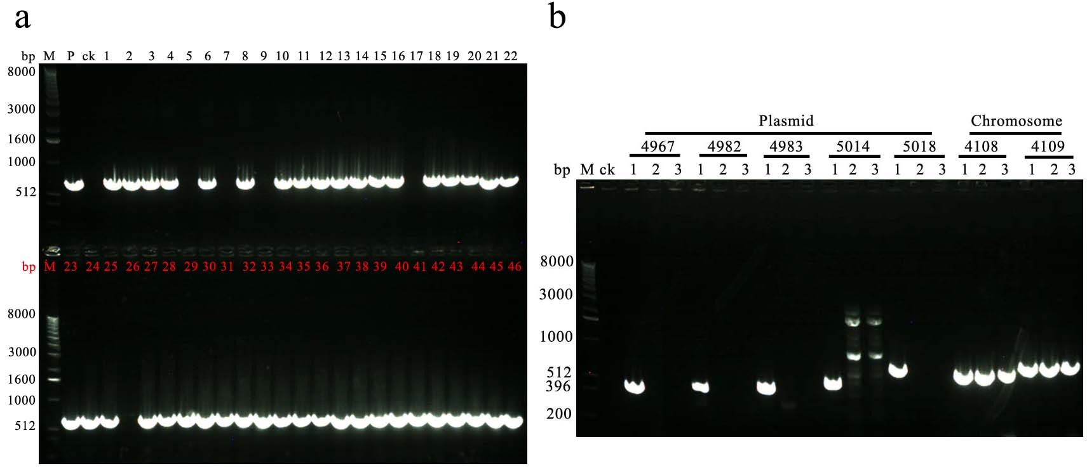
Figure S4. Verification of the elimination of the plasmid p6 for 151-6. (a)Selection of elimination of the plasmid p6 by PCR with the primers 4963CDS-F/4963CDS-R (located on plasmid p6). Lanes: M, 1-kb DNA ladder; templates: ck, ddH₂O; P, 151-6 genome DNA; 1-46: Random selected single colony strain. (b) Identification of elimination of the plasmid p6 by PCR with the primers 4967CDS-F/4967CDS-R, 4982CDS-F/4982CDS-R, 4983CDS-F/4983CDS-R, 5014CDS-F/5014CDS-R, 5018CDS-F/5018CDS-R (located on plasmid p6), 4108CDS-F/4108CDS-R and, 4109CDS-F/4109CDS-R (located on chromosome of 151-6). Lanes: M, 1-kb DNA ladder; templates: ck, ddH₂O; 1, 151-6 genome DNA; 2: Genome DNA of elimination of the plasmid p25 151-6△5 (marked with the red arrow); 3: Genome DNA of elimination of the plasmid p6 151-6△7(marked with the red arrow).

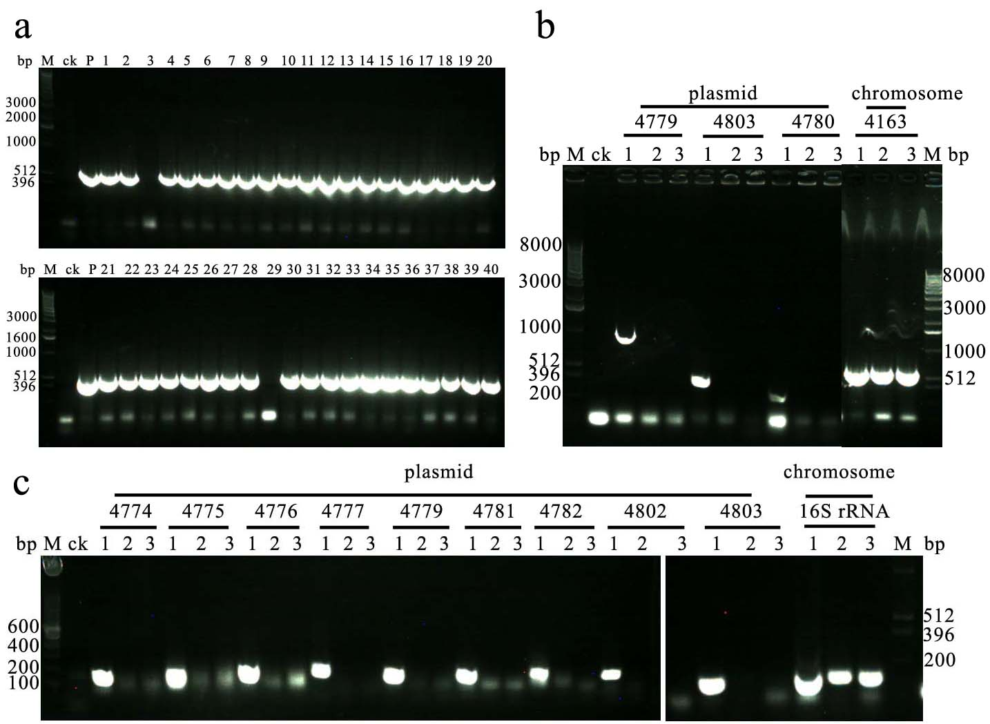
Figure S5. Verification of the elimination of the plasmid p25 for 151-25. (a)Selection of elimination of the plasmid p25 by PCR with the primers 4803CDS-F/4803CDS-R (located on plasmid p25). Lanes: M, 1-kb DNA ladder; templates: ck, ddH₂O; P, 151-25 genome DNA; 1-40: Random selected single colony strain. (b) Identification of elimination of the plasmid p25 by PCR with the primers 4779CDS-F/4779CDS-R, 4803CDS-F/4803CDS-R, 4780CDS-F/4780CDS-R (located on plasmid p25) and 4163CDS-F/4163CDS-R (located on chromosome of 151-25). Lanes: M, 1-kb DNA ladder; templates: ck, ddH₂O; 1, 151-25 genome DNA; 2: Genome DNA of elimination of the plasmid p25 151-25△3 (marked with the red arrow); 3: Genome DNA of elimination of the plasmid p25 151-25△29(marked with the red arrow). (c) Identification of elimination of the plasmid p25 by PCR with the 151-25 qRT-PCR primers. Lanes: M, 100-bp DNA ladder; templates: ck, ddH₂O; 1, 151-25 genome DNA; 2: Genome DNA of elimination of the plasmid p25 151-25△3; 3: Genome DNA of elimination of the plasmid p25 151-25△29.
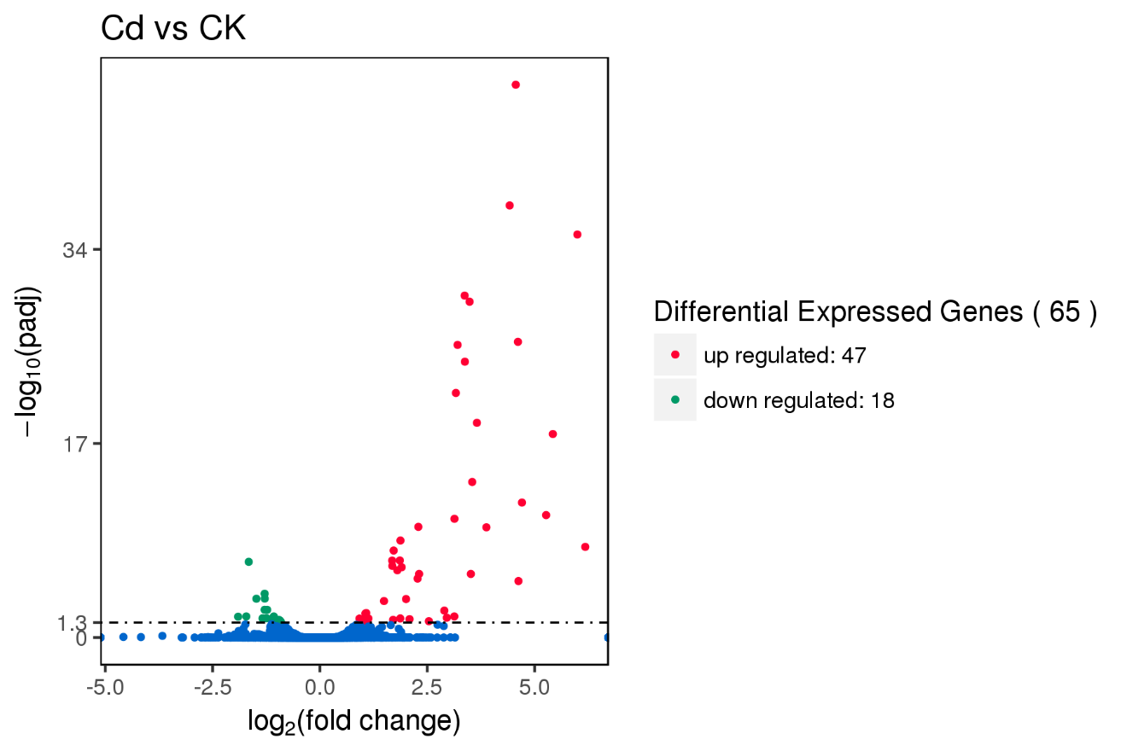
Figure S6. Volcano map of differentially expressed genes of 151-25.
Figure S7. Transcription analysis of up-regulated genes based on RNA sequencing and examination of Cd-MIC for recombinant B. subtilis containing the operon of 151-25. (a) Transcription analysis of the chromosomal genes orf666, 667, 668, 1240, 1241, 2329, 2552, 2553, 2588, 2757, 3804, 3805, 3806, 3808, 3892, 3894, 4580, 4581 and 4582 in 151-25 cultured with 0.1 mM Cd²⁺ (Cd) in comparison with a culture grown in the absence of Cd²⁺ (CK) using qRT-PCR. Transcript levels of the tested genes were normalized to the 16S rRNA gene. (b) Determination of Cd-MIC for recombinant B. subtilis containing the vectors pUBC19 (negative control), 666-667-668-pUBC19, 1240-1241-pUBC19, 3892-2894-pUBC19 and 4802-4803-pUBC19 with varying concentrations of Cd²⁺ (0, 0.02, 0.04, 0.06, 0.08, 0.1, 0.2, 0.3, 0.4, 0.5, 0.6, 0.7, 0.8, 0.9, 1.0 and 1.1 mM).
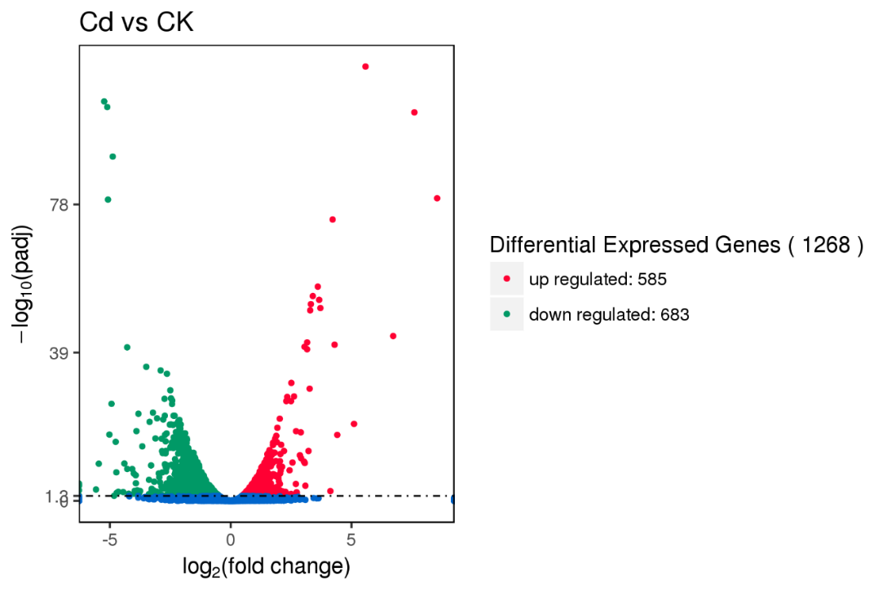
Figure S8. Volcano map of differentially expressed genes of 151-6.

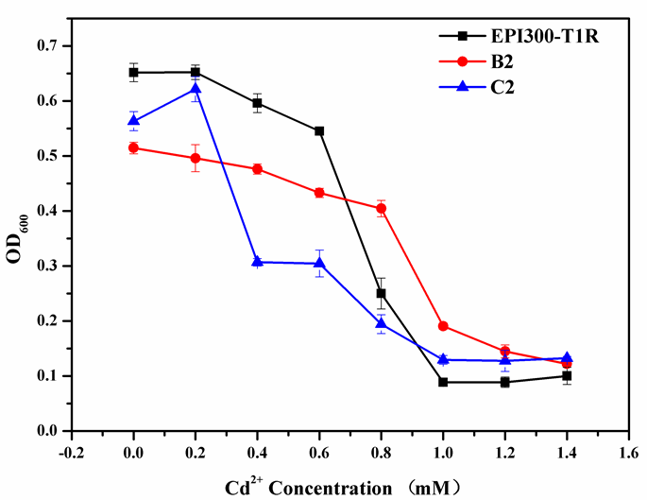
Figure S9. Evaluation of Cd-MIC of B2 and C2. B2 and C2 were screened clones in E. coli fosmid library for 151-6. EPI300-T1R was negative control E. coli strain.

Figure S10. Alignment of the putative cadA amino acid sequence (4111, 4802) from 151-6 and 151-25 versus the CadA from S. aureus. Dashes indicate gaps introduced to optimize alignment, asterisk indicate identities, and dots indicate conservative amino acid replacements, semicolons and dots indicate difference, and the red horizontal line indicate a conserved (Cys-Pro-Cys) tripeptide.

Figure S11. Alignment of the putative cadc amino acid sequence (4112, 4803) from 151-6 and 151-25 versus the CadC from S. aureus. Dashes indicate gaps introduced to optimize alignment, asterisk indicate identities, and dots indicate conservative amino acid replacements, semicolons and dots indicate difference and the red arrow represent conserved Cys sites.
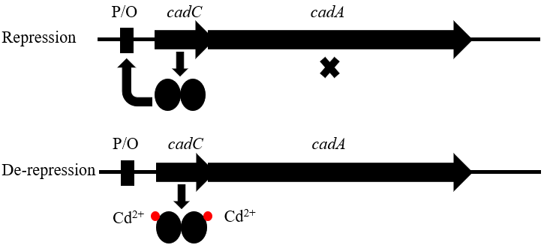
Figure S12. The hypothetical cad system model of B. marisflavi 151-25

